# 

**Hospital Management System**

#### A PROJECT REPORT

##### Submittedby

**Nishchay (22BCS10648)**

***in partial fulfillment for the award of the degree of***

## BACHELOR OF ENGINEERING

**IN**

COMPUTER SCIENCE ENGINEERING



#### Chandigarh University

April-2025



## BONAFIDE CERTIFICATE

Certified that this project report **“ Hospital Management System”** is the bonafide work of **“Parveen Kumar(22BCS15865) , Ranit(22BCS14455)”** who carried out the project work under my/our supervision.

###### SIGNATURE

Dr.Suresh Kaswan

###### HEAD OF THE DEPARTMENT

###### SIGNATURE

Radha(E16496)

###### SUPERVISOR

Submitted for the project viva-voce examination held on

**INTERNAL EXAMINER EXTERNAL EXAMINER**

## TABLE OF CONTENTS

List of Figures i

List of Tables ii

Abstract iii

Graphical Abstract iv

Abbrevations v

Symbols vi

Chapter 1. 4

* 1. **....................................................................................................................................**
     1. **……….....................................................................................................................**
  2. **...................................................................................................................................**

#### Chapter 2. ................................................................................................................

* 1. **...................................................................................................................................**
  2. **...................................................................................................................................**

**Chapter 3. ................................................................................................................**

**Chapter 4. ………………………….……………………………………………...**

**Chapter 5. …………………………………………………………………...…… References (If Any) ..................................................................................................**

### List of Figures

**Figure 3.1 ………………………………………………………………………………….**

**Figure 3.2 ………………………………………………………………………………….**

**Figure 4.1 …………………………………………………………………………….……**

### List of Tables

**Table 3.1 ………………………………………………………………………………….**

**Table 3.2 ………………………………………………………………………………….**

**Table 4.1 …………………………………………………………………………….……**

## ABSTRACT

This project report presents the design and implementation of a comprehensive **Hospital Management System (HMS)** developed using Java, Servlets, JSP, and XML technologies. In today’s fast-paced and technology-driven healthcare environment, the need for an efficient, reliable, and scalable hospital management solution has become essential. Hospitals and healthcare institutions face significant challenges when managing large volumes of patient records, appointments, clinical workflows, billing procedures, and administrative operations manually. This leads to inefficiencies, data redundancy, increased waiting time for patients, and overall dissatisfaction for both healthcare professionals and recipients of care.

The primary goal of the HMS project is to streamline these operations through a centralized, automated system that ensures secure data storage, consistent access to information, and user-friendly interaction for various stakeholders including doctors, administrative staff, and patients. The proposed system enables hospitals to maintain digital records of patients, track appointments, manage doctor and staff schedules, generate bills and invoices, and handle medicine inventory efficiently. It also supports role-based access to ensure the security and privacy of patient information, which is a critical requirement in the healthcare domain.

This software solution is web-based and follows a client-server architecture, making it accessible through any web browser and scalable for different hospital sizes. Java Servlets serve as the core backend engine to handle business logic and server-side processing. JSP is used for rendering the dynamic front-end interface. The integration of XML and MySQL provides flexibility in storing and managing structured data, allowing for easier portability, backups, and third-party integrations.

From a development perspective, the project followed the Agile methodology, where the design and implementation were divided into iterative sprints, allowing for regular feedback and continuous improvement. The project was planned using Gantt charts and managed using tools such as Trello, Git, and GitHub. UML tools were utilized for creating use case diagrams, class diagrams, sequence diagrams, and deployment diagrams to visualize system architecture and data flow effectively.

**ABBREVIATIONS**

* HMS – Hospital Management System
* JSP – Java Server Pages
* XML – Extensible Markup Language
* UI – User Interface
* DBMS – Database Management System
* SQL – Structured Query Language
* IDE – Integrated Development Environment
* JVM – Java Virtual Machine
* UAT – User Acceptance Testing
* API – Application Programming Interface
* UML – Unified Modeling Language
* DFD – Data Flow Diagram
* CRUD – Create, Read, Update, Delete
* JDBC – Java Database Connectivity
* OS – Operating System

## CHAPTER 1.

**INTRODUCTION**

#### Client Identification/Need Identification/Identification of relevant Contemporary issue

In India, healthcare infrastructure faces significant challenges with manual processes still being prevalent in many hospitals. According to a 2022 report by NITI Aayog, more than 60% of small to mid-size hospitals rely on paper-based systems, leading to delayed diagnostics, mismanaged appointments, and inefficient billing. Moreover, a survey conducted by the Indian Medical Association (IMA) indicated that 75% of healthcare professionals believe that digitization of hospital operations could enhance efficiency and patient satisfaction.

There is a growing need for a comprehensive digital system to manage hospital operations. As patient loads increase and demand for timely healthcare grows, automating these processes becomes not only a convenience but a necessity. Government initiatives like Ayushman Bharat and the National Digital Health Mission further support the transition toward digital healthcare infrastructure, underlining the contemporary relevance of the problem.

This project addresses a real-world consultancy problem where hospitals seek robust solutions to manage data securely, streamline operations, and provide better patient outcomes through an integrated system.

#### Identification of Problem

#### Hospitals often face critical challenges in managing and maintaining accurate, timely, and accessible patient and administrative data. The absence of a centralized and reliable system frequently leads to miscommunication between departments, delays in patient care, duplication of records, and inefficiencies in managing hospital workflows. As the volume of patients and medical data continues to grow, these inefficiencies become more prominent, potentially compromising the quality of healthcare delivery.

#### Furthermore, manual processes used for scheduling, billing, and resource allocation are prone to human error, which can lead to financial discrepancies, overcrowding, and underutilization of staff or medical equipment. These problems collectively reduce operational efficiency and patient satisfaction, creating an urgent need to address the underlying issues in hospital data and process management.

#### Identification of Tasks

1. **Requirement Analysis:**

* Conduct stakeholder meetings and surveys
* Understand hospital workflows, user roles, and required modules

**2. System Design:**

* Develop high-level architecture and data flow
* Design UI mockups and system components

**3. Technology Selection:**

* Choose development platforms, backend tools, and database systems

**4. Development:**

* Frontend implementation using JSP.
* Backend development using Java and Servlets
* XML/MySQL database configuration

#### Timeline

|  |  |  |
| --- | --- | --- |
| **Phase** | **Duration** | **Month(s)** |
| Requirement Analysis | 1 week | January (Week 1) |
| System Design | 2 weeks | January (Week 2-3) |
| Technology Selection | 1 week | January (Week 4) |
| UI & Frontend Development | 2 weeks | February (Week 1-2) |
| Backend Development | 2.5 weeks | February (Week 3) – March (Week 1) |
| Database Integration | 1.5 weeks | March (Week 2-3) |
| System Integration | 1 week | March (Week 4) |
| Testing & Validation | 2 weeks | April (Week 1-2) |
| Documentation & Reporting | 2 weeks | April (Week 3-4) |

#### Organization of the Report

#### This report is structured to provide a comprehensive overview of the design and implementation process of the Hospital Management System. Each chapter focuses on a specific aspect of the project to maintain clarity and logical flow.

**Chapter 1: Introduction** – Presents the background, identifies the real-world problem,

outlines the key tasks, and introduces the structure of the report.

**Chapter 2: Design Flow/Process** – Describes the design methodology, evaluation of

alternatives, consideration of constraints, and the selection of the final design with detailed

implementation plans.

**Chapter 3: Results Analysis and Validation** – Covers the development process, tools used,

implementation results, testing phases, and performance validation.

**Chapter 4: Conclusion and Future Work** – Summarizes the outcomes of the project,

analyzes any deviations from expected results, and suggests future enhancements.

**References** – Lists the research papers, tools, and documentation referred during the project.

**Appendix** – Contains additional information like screenshots and code snippets that support

the project but are not included in the main chapters.

## CHAPTER 2.

**DESIGN FLOW/PROCESS**

#### Evaluation & Selection of Specifications/Features

A review of various existing hospital management systems and healthcare IT literature revealed that an ideal solution should automate routine hospital operations while maintaining high standards of accuracy, security, and usability. The goal is to ensure an efficient and seamless experience for both medical staff and patients.

Based on this evaluation, the following key features have been identified as essential for the proposed Hospital Management System:

* **Patient Registration and Management**: Enables quick registration of new patients and updates to existing patient profiles with personal, medical, and contact details.
* **Appointment Scheduling**: Allows patients to book appointments with doctors based on availability and department-specific queues.
* **Doctor and Staff Management**: Maintains records of doctors, nurses, and administrative staff including their schedules, availability, and contact information.
* **Billing and Invoice Generation**: Automates the billing process including consultation fees, lab tests, medicines, and other services, with options to print or email invoices.
* **Medical Records Management**: Stores and manages patients’ medical history, treatment records, prescriptions, diagnostic reports, and discharge summaries.
* **Inventory and Pharmacy Management**: Tracks stock levels of medicines, equipment, and medical supplies and alerts on low stock situations.
* **User Authentication and Role Management**: Ensures data security by restricting access to authorized users based on their roles (admin, doctor, nurse, receptionist, etc.).
* **Reports and Analytics**: Generates reports for patient visits, doctor schedules, billing, and other administrative insights to aid decision-making.
* **Emergency Handling Module**: Allows quick registration and triage handling of emergency cases for faster admission and treatment.

These features were selected based on their impact on hospital efficiency, patient experience, and their presence in standard healthcare software solutions.

#### Design Constraints

**Regulatory Compliance**: The system must comply with healthcare data protection regulations such as HIPAA or its local equivalents.

**Economic Constraints**: The design should aim for cost-effective development and deployment, especially considering budget constraints of small and mid-sized hospitals.

**Environmental Constraints**: Hosting and server solutions should consider energy efficiency and minimal hardware waste.

**Health Constraints**: The interface should be designed to minimize stress and maximize accessibility for users working in high-pressure medical environments.

**Manufacturability**: The software must be easily installable and deployable across various hardware and operating systems commonly used in hospitals.

**Safety Constraints**: Data accuracy and integrity must be ensured to avoid medical errors.

**Professional Ethics**: User data must be handled with confidentiality and integrity, ensuring no misuse or unauthorized access.

**Social Constraints**: The interface should be inclusive and usable by users with different language or technology literacy levels.

**Political Constraints**: Compliance with government initiatives and health sector digitalization policies.

**Cost Constraints**: The project must operate within a limited budget, including the costs of tools, technologies, hosting, and maintenance.

#### Analysis and Feature finalization subject to constraints

Based on the identified design constraints, the features proposed earlier were carefully reviewed and refined. The objective was to maintain a balance between system performance, usability, and compliance, while adhering to economic and technological limitations.

* **Removed**:
  + Real-time patient monitoring (postponed to future version due to hardware and integration costs)
  + AI-based prediction systems (excluded due to current scope and complexity)
* **Modified**:
  + **Reports and Analytics** simplified to provide basic downloadable reports instead of interactive dashboards
  + **Inventory Management** scaled down to track only medicine stock, excluding surgical tools and equipment
* **Added**:
  + **User Activity Logging** to monitor actions and maintain system integrity for audit purposes
  + **Simple Notification System** via email alerts for appointments and billing reminders

These adjustments ensure that the system remains functional, scalable, and within budget while still addressing core operational needs of hospitals.

#### Design Flow

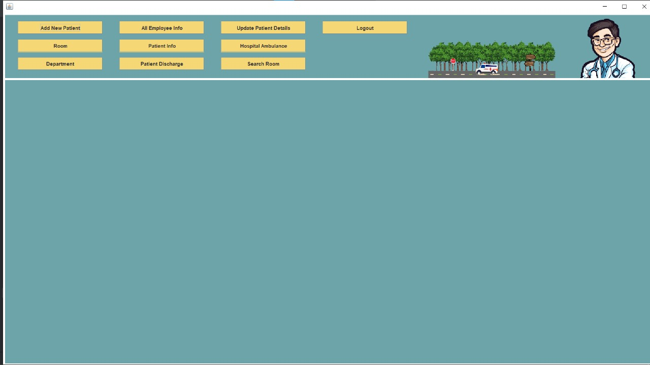

#### 

#### Design selection

After evaluating both alternatives, the **web-based client-server architecture** was selected as the most suitable design for the Hospital Management System.

|  |  |  |
| --- | --- | --- |
| **Criteria** | **Web-Based System (Java EE)** | **Desktop Application (Python + SQLite)** |
| Accessibility | Accessible via any browser | Limited to specific devices |
| Deployment | Centralized | Requires installation on each device |
| Maintenance | Easier centralized updates | Difficult version control |
| Scalability | Highly scalable | Limited to local machines |
| Collaboration Support | Real-time multi-user access | Not ideal for multi-user scenarios |
| Cost | Moderate setup, lower long-term cost | Low initial cost, high maintenance effort |
| Data Consistency | High | Risk of redundant/unsynced data |

The web-based model offers superior **scalability**, **accessibility**, and **centralized control**, making it ideal for hospital environments that demand consistent performance across multiple departments. Despite a slightly higher initial setup cost, its long-term benefits in ease of maintenance, data integrity, and multi-user access significantly outweigh those of the desktop model. Furthermore, it aligns better with modern enterprise infrastructure standards and can be more easily integrated into cloud-based or mobile platforms in future enhancements.

#### Implementation plan/methodology

The implementation of the Hospital Management System follows a modular, client-server approach ensuring efficient data handling and user interaction.

**System Flow (Descriptive):**

1. User opens the system in a web browser.
2. Requests are routed to the Apache Tomcat server.
3. The server forwards them to the appropriate Java Servlet.
4. Servlet executes logic via Java classes (Model).
5. Model communicates with XML/MySQL database to retrieve/store data.
6. Data is passed back through the servlet to JSP.
7. JSP renders output on the browser.

**Modules Implemented:**

* **Login Module:** Handles user authentication and role-based access.
* **Patient Module:** Registers patients, manages visits and history.
* **Doctor Module:** Manages schedules, availability, and assignments.
* **Appointment Module:** Allows appointment booking with timing validation.
* **Billing Module:** Computes costs and generates invoices.
* **Inventory Module:** Tracks medicine stock with alerts.

## CHAPTER 3.

**RESULTS ANALYSIS AND VALIDATION**

#### Implementation of solution

Analysis Tools:For requirements gathering and system analysis, use case diagrams and DFDs (Data Flow Diagrams) were created using tools such as Lucidchart and draw.io. These diagrams helped visualize the structure, user interactions, and data movement within the system.

Design Drawings/Schematics:The high-level system architecture and component designs were drafted to illustrate interactions between the front-end, back-end, and database layers. UML diagrams such as class and sequence diagrams were used to represent object-oriented interactions. UI wireframes were created to outline the user interface layout for each module.

Report Preparation:Project documentation and reports were prepared using Microsoft Word and LaTeX. Tables, figures, and formatting followed the UG Mini Project Report Format 2025. The report was version-controlled using Git to manage contributions and iterations.

Project Management and Communication:The team adopted Agile principles for project execution. Tasks were managed using Trello and GitHub Projects. Google Meet and WhatsApp were used for communication and regular updates. Weekly reviews ensured alignment and milestone tracking.

Testing, Characterization, and Data Validation:System testing was carried out in multiple phases including unit testing of individual modules using JUnit, integration testing for end-to-end workflow validation, and user acceptance testing. Sample patient and billing data were used for validation to ensure accurate record handling and report generation.

## CHAPTER 4.

**CONCLUSION AND FUTURE WORK**

#### Conclusion

The development of the Hospital Management System has successfully achieved the goal of automating essential hospital operations such as patient registration, appointment booking, billing, and medical record management. The system ensures greater efficiency, accuracy, and accessibility of healthcare data, ultimately contributing to improved patient care and streamlined administrative workflows.

The expected outcomes included the reduction of manual paperwork, enhancement of operational speed, improved data consistency, and user-friendly access control across departments. These objectives were largely met. Stakeholder feedback during user testing confirmed that the system made day-to-day hospital activities significantly more organized and less error-prone.

However, minor deviations were noted during implementation. For example, integration with third-party pharmacy databases and real-time alert systems was deferred due to time constraints and integration complexity. Additionally, some initial performance issues were observed during concurrent user sessions, which were mitigated by optimizing database queries and refining backend logic.

In conclusion, the system demonstrates strong functionality and has laid a solid foundation for further scalability and integration with modern health IT infrastructures.

#### Future work

As technology and healthcare needs continue to evolve, the Hospital Management System

has several opportunities for future enhancement and modernization:

* **Mobile Application Integration**: Developing an Android/iOS companion app for doctors and patients will enable remote appointment booking, access to records, and real-time updates.
* **Cloud Deployment**: Migrating the system to a cloud platform such as AWS or Azure for improved scalability, reliability, and remote accessibility.
* **AI-Powered Features**: Integrating artificial intelligence for features like symptom-based appointment suggestions, automatic diagnosis recommendations, and treatment predictions.
* **Telemedicine Support**: Adding video consultation features to allow remote healthcare delivery, especially valuable in rural or underserved areas.
* **IoT Integration**: Enabling integration with wearable devices or IoT-enabled hospital equipment to monitor vital signs in real-time and alert caregivers during emergencies.
* **Data Analytics Dashboard**: Advanced dashboards using business intelligence tools to track patient flow, revenue trends, and performance KPIs.
* **Multilingual Support**: Incorporating regional language options to improve accessibility for diverse user groups.
* **Blockchain for Health Records**: Using blockchain technology to secure and decentralize patient records while ensuring immutability and traceability.

These future improvements aim to expand the system’s utility, enhance data-driven decision-making, and meet growing healthcare demands in an increasingly digital world.

**REFERENCES**

1. Java Servlet Documentation – Oracle
2. JSP Developer Guide – Oracle
3. XML Schema W3C Recommendations
4. NITI Aayog Digital Health Report 2022
5. Indian Medical Association (IMA) Survey 2022
6. MySQL Documentation – Oracle
7. Java API Reference – Oracle
8. Apache Tomcat User Guide
9. GitHub Documentation – GitHub Docs
10. World Health Organization (WHO) – Digital Health Reports
11. Ayushman Bharat Digital Mission – Ministry of Health
12. Healthcare Information and Management Systems Society (HIMSS) Reports
13. Agile Methodology Whitepaper – Atlassian
14. Hospital Management with Java EE – SpringerLink
15. Draw.io System Design Tutorials
16. Lucidchart for Healthcare IT Mapping
17. OWASP Top 10 Security Guidelines
18. IEEE Standards for Health Informatics
19. User Experience in Healthcare IT – UX Collective
20. Clinical Decision Support Systems – NCBI

**APPENDIX**

The appendix section provides supplementary materials that support the understanding and validation of the Hospital Management System. These resources serve as references for visual confirmation, testing, and presentation of actual implementation.

**Appendix A: System Screenshots**

* Login Page
* Patient Registration Form
* Appointment Scheduling Interface
* Doctor Dashboard
* Billing Module Interface
* Inventory Monitoring Panel
* Admin Report Dashboard

**Appendix B: Sample Database Entries**

* Patient Table: ID, Name, Age, Gender, Contact, Address
* Doctor Table: ID, Name, Department, Availability
* Appointment Table: Patient ID, Doctor ID, Date, Time
* Billing Table: Patient ID, Service Type, Amount
* Inventory Table: Medicine Name, Quantity, Expiry Date

**Appendix C: Data Flow Diagrams and System Architecture**

* Level 0 DFD – System Overview
* Level 1 DFD – Appointment & Billing Process
* UML Class Diagram for System Modules
* Deployment Diagram for Hosting and Server Architecture

**Appendix D: Test Cases and Results**

* Unit test results for each module
* Integration test checklist
* Screenshots of passed and failed test scenarios

**USER MANUAL**

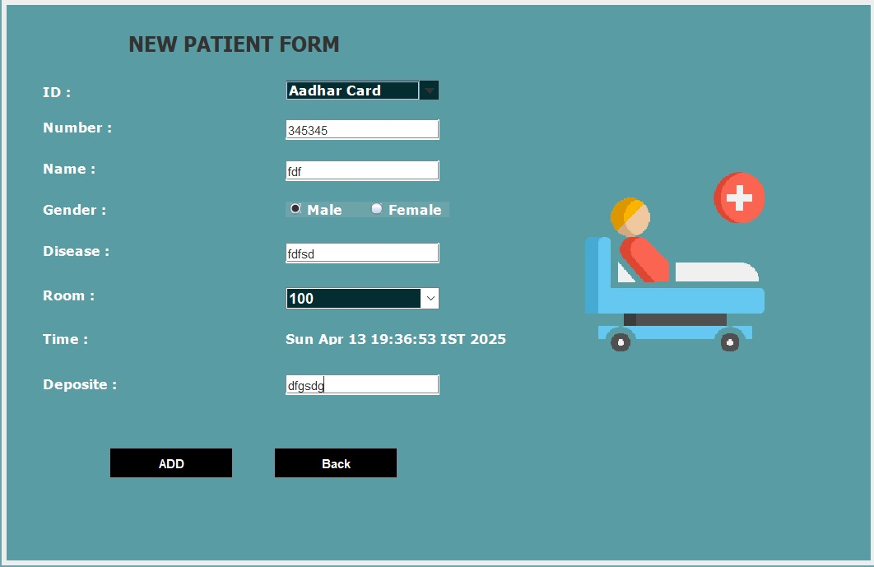(Complete step by step instructions along with pictures necessary to run the project)

